Experiment-6

**Aim** Hands-on experimentation of ATMega32 UART programming in C.

**Objectives:** After successfully completing this experiment students will be able to,

* Use C language for ATMega32 microcontroller programming on AVR Studio.
* Experiment with UARTMega32 on ATMega32 AVR Development Board and learn hands-on serial programming in ATMega32.

# Equipment required:

* Windows7 or later based host computer
* ATMega32 Development Board
* USBasp Programmer
* Jumper Wires
* USB to TTL converter

# Software required:

* AVR Studio7 installation setup
* USBasp driver installation setup

# Theory:

**Introduction**

AVR ATmega has flexible USART, which can be used for serial communication with other devices like computers, serial GSM, GPS modules, etc.

Before beginning with AVR USART, we will walk through the basics of serial communication.

**Serial data framing**

While sending/receiving data, some bits are added for the purpose of knowing the beginning/ending of data, etc. commonly used structure is: 8 data bits, 1 start bit (logic 0), and 1 stop bit (logic 1), as shown:

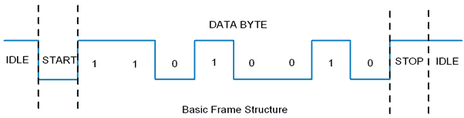

There are also other supported frame formats available in UART, like parity bit, variable data bits (5-9 data bits).

**Speed (Baud rate)**

As we know the bit rate is “Number of bits per second (bps)”, also known as Baud rate in Binary system. Normally this defines how fast the serial line is. There are some standard baud rates defined e.g. 1200, 2400, 4800, 19200, 115200 bps, etc. Normally 9600 bps is used where speed is not a critical issue.

**Wires and Hardware connection**

Normally in USART, we only need Tx (Transmit), Rx(Receive), and GND wires.

* AVR ATmega USART has a TTL voltage level which is 0 v for logic 0 and 5 v for logic 1.
* In computers and most of the old devices, RS232 protocol is used for serial communication, where normally 9 pin ‘D’ shape connector is used. RS232 serial communication has different voltage levels than ATmega serial communication i.e. +3 v to +25 v for logic zero and -3 v to -25 v for logic 1.
* So to communicate with RS232 protocol, we need to use a voltage level converter like MAX232 IC.

Although there are 9 pins in the DB9 connector, we don’t need to use all the pins. Only 2nd Tx(Transmit), 3rd Rx(Receive), and 5th GND pin need to be connected.

With a new PC and laptops, there is no RS232 protocol and DB9 connector. We have to use serial to the USB connector. There are various serial to USB connectors available e.g. CP2102, FT232RL, CH340, etc.

To see serial communication, we can use a serial terminal like Realterm, Teraterm, etc. By selecting the serial port number (COM port in windows) and baud rate, we can open a serial port for communication.

As stated in the datasheet ATmega 16/32 USART has the following features

* Full Duplex Operation (Independent Serial Receive and Transmit Registers)
* Asynchronous or Synchronous Operation
* Master or Slave Clocked Synchronous Operation
* High-Resolution Baud Rate Generator
* Supports Serial Frames with 5, 6, 7, 8, or 9 Data Bits and 1 or 2 Stop Bits
* Odd or Even Parity Generation and Parity Check Supported by Hardware
* Data OverRun Detection
* Framing Error Detection
* Noise Filtering Includes False Start Bit Detection and Digital Low Pass Filter
* Three Separate Interrupts on TX Complete, TX Data Register Empty, and RX Complete
* Multi-processor Communication Mode
* Double Speed Asynchronous Communication Mode

**Programming of USART in AVR**

To program, first, we need to understand the basic registers used for USART

**AVR basic Registers**

1. **UDR: USART Data Register**

It has basically two registers, one is Tx. Byte and the other is Rx Byte. Both share the same UDR register. Do remember that, when we write to the UDR reg. Tx buffer will get written and when we read from this register, Rx Buffer will get read. Buffer uses the FIFO shift register to transmit the data.

       2. **UCSRA**: USART Control and Status Register A. As the name suggests, is used for control and status flags. In a similar fashion, there are two more USART control and status registers, namely UCSRB and UCSRC.

       3. **UBRR**: USART Baud Rate Register, this is a 16-bit register used for the setting baud rate.

We will see this register in detail:

**UCSRA: USART Control and Status Register A**



* **Bit 7 – RXC:** USART Receive Complete

This flag bit is set when there is unread data in UDR. The RXC Flag can be used to generate a Receive Complete interrupt.

* **Bit 6 – TXC:**USART Transmit Complete

This flag bit is set when the entire frame from Tx Buffer is shifted out and there is no new data currently present in the transmit buffer (UDR). The TXC Flag bit is automatically cleared when a transmit complete interrupt is executed, or it can be cleared by writing a one to its bit location. The TXC Flag can generate a Transmit Complete interrupt.

* **Bit 5 – UDRE:** USART Data Register Empty

If UDRE is one, the buffer is empty which indicates the transmit buffer (UDR) is ready to receive new data. The UDRE Flag can generate a Data Register Empty Interrupt. UDRE is set after a reset to indicate that the transmitter is ready.

* **Bit 4 – FE:** Frame Error
* **Bit 3 – DOR:** Data OverRun

This bit is set if a Data OverRun condition is detected. A Data OverRun occurs when the receive buffer is full (two characters) and a new character is waiting in the receive Shift Register.

* **Bit 2 – PE:** Parity Error
* **Bit 1 – U2X:** Double the USART Transmission Speed
* **Bit 0 – MPCM:** Multi-processor Communication Mode

**UCSRB: USART Control and Status Register B**



* **Bit 7 – RXCIE:** RX Complete Interrupt Enable

                   Writing one to this bit enables interrupt on the RXC Flag.

* **Bit 6 – TXCIE:** TX Complete Interrupt Enable

                   Writing one to this bit enables interrupt on the TXC Flag.

* **Bit 5 – UDRIE:** USART Data Register Empty Interrupt Enable

                   Writing one to this bit enables interrupt on the UDRE Flag.

* **Bit 4 – RXEN:** Receiver Enable

                  Writing one to this bit enables the USART Receiver.

* **Bit 3 – TXEN:** Transmitter Enable

                  Writing one to this bit enables the USART Transmitter.

* **Bit 2 – UCSZ2:** Character Size

The UCSZ2 bits combined with the UCSZ1:0 bit in UCSRC sets the number of data bits (Character Size) in a frame the receiver and transmitter use.

* **Bit 1 – RXB8:** Receive Data Bit 8
* **Bit 0 – TXB8:** Transmit Data Bit 8

**UCSRC: USART Control and Status Register C**



* **Bit 7 – URSEL:** Register Select

This bit selects between accessing the **UCSRC** or the **UBRRH** Register, as both register shares the same address. The URSEL must be one when writing the UCSRC or else data will be written in the UBRRH register.

* **Bit 6 – UMSEL:** USART Mode Select

                  This bit selects between the Asynchronous and Synchronous mode of operation.

**0 =** Asynchronous Operation

**1 =**Synchronous Operation

* **Bit 5:4 – UPM1:0**: Parity Mode

These bits enable and set the type of parity generation and check. If parity a mismatch is detected, the PE Flag in UCSRA will be set.

| **UPM1** | **UPM0** | **Parity Mode** |
| --- | --- | --- |
| 0 | 0 | Disabled |
| 0 | 1 | Reserved |
| 1 | 0 | Enabled, Even Parity |
| 1 | 1 | Enabled, Odd Parity |

* **Bit 3 – USBS**: Stop Bit Select

This bit selects the number of Stop Bits to be inserted by the Transmitter. The Receiver ignores this setting.

**0 =** 1-bit

**1 =**2-bit

* **Bit 2:1 – UCSZ1:0**: Character Size

The UCSZ1:0 bits combined with the UCSZ2 bit in UCSRB sets the number of data bits (Character Size) in a frame the Receiver and Transmitter use.

| **UCSZ2** | **UCSZ1** | **UCSZ0** | **Character Size** |
| --- | --- | --- | --- |
| 0 | 0 | 0 | 5-bit |
| 0 | 0 | 1 | 6-bit |
| 0 | 1 | 0 | 7-bit |
| **0** | **1** | **1** | **8-bit** |
| 1 | 0 | 0 | Reserved |
| 1 | 0 | 1 | Reserved |
| 1 | 1 | 0 | Reserved |
| 1 | 1 | 1 | 9-bit |

* **Bit 0 – UCPOL:** Clock Polarity

This bit is used for synchronous mode only. Write this bit to zero when the asynchronous mode is used.

**UBRRL and UBRRH: USART Baud Rate Registers**

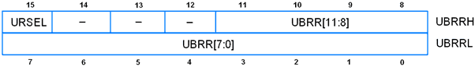

* **Bit 15 – URSEL:** Register Select

This bit selects between accessing the **UCSRC** or the **UBRRH** Register, as both register shares the same address. The URSEL must be one when writing the UCSRC or else data will be written in the UBRRH register.

* **Bit 11:0 – UBRR11:0:** USART Baud Rate Register.

            Used to define the baud rate

\mathbf{UBBR = \frac{Fosc}{16 * Baud Rate} - 1}                   \mathbf{Baud Rate = \frac{Fosc}{16 * (UBBR + 1)}}

Example: suppose Fosc=8 MHz and required baud rate= 9600 bps.

Then the value of **UBRR= 51.088 i.e. 51.**

We can also set this value by c code using pre-processor macro as follow.

#define F_CPU 8000000UL /* Define frequency here its 8MHz */

#define USART_BAUDRATE 9600

#define BAUD_PRESCALE (((F_CPU / (USART_BAUDRATE * 16UL))) - 1)

BAUD_PRESCALE is the value that we have to load in the UBRR register to set the defined baud rate.

**Programming steps**

**Initialization of USART**

1. Enable transmission and reception by using the UCSRB register.
2. Set data bit size to 8 bit by using the UCSRC register.
3. Set baud rate using the UBRR register.

void UART_init(long USART_BAUDRATE)

{

UCSRB |= (1 << RXEN) | (1 << TXEN); /* Turn on transmission and reception */

UCSRC |= (1 << URSEL) | (1 << UCSZ0) | (1 << UCSZ1);/* Use 8-bit char size */

UBRRL = BAUD_PRESCALE; /* Load lower 8-bits of the baud rate */

UBRRH = (BAUD_PRESCALE >> 8); /* Load upper 8-bits*/

}

**Receiving Character**

Monitor the RXC bit in UCSRA. RXC bit indicates receive complete status.

unsigned char UART_RxChar()

{

while ((UCSRA & (1 << RXC)) == 0);/* Wait till data is received */

return(UDR); /* Return the byte */

}

**Transmitting Character**

Monitor the UDRE bit from UCSRA. When the UDRE flag becomes one, which indicates the transmitting buffer is empty and ready to accept another byte.

void UART_TxChar(char ch)

{

while (! (UCSRA & (1<<UDRE))); /* Wait for empty transmit buffer */

UDR = ch ;

}

**Example**

Program for echo test. In this program, the ATmega 16 controller will receive a character and send it back. We can use the PC terminal to observe echo.

/*

ATmega 16 UART echo program

http://www.electronicwings.com

*/

#define F_CPU 8000000UL /* Define frequency here its 8MHz */

#include <avr/io.h>

#include <util/delay.h>

#include <stdlib.h>

#include <stdio.h>

//#define USART_BAUDRATE 9600

#define BAUD_PRESCALE (((F_CPU / (USART_BAUDRATE * 16UL))) - 1)

void UART_init(long USART_BAUDRATE)

{

UCSRB |= (1 << RXEN) | (1 << TXEN);/* Turn on transmission and reception */

UCSRC |= (1 << URSEL) | (1 << UCSZ0) | (1 << UCSZ1);/* Use 8-bit character sizes */

UBRRL = BAUD_PRESCALE; /* Load lower 8-bits of the baud rate value */

UBRRH = (BAUD_PRESCALE >> 8); /* Load upper 8-bits*/

}

unsigned char UART_RxChar()

{

while ((UCSRA & (1 << RXC)) == 0);/* Wait till data is received */

return(UDR); /* Return the byte*/

}

void UART_TxChar(char ch)

{

while (! (UCSRA & (1<<UDRE))); /* Wait for empty transmit buffer*/

UDR = ch ;

}

void UART_SendString(char *str)

{

unsigned char j=0;

while (str[j]!=0) /* Send string till null */

{

UART_TxChar(str[j]);

j++;

}

}

int main()

{

char c;

UART_init(9600);

UART_SendString("\n\t Echo Test ");

while(1)

{

c=UART_RxChar();

UART_TxChar(c);

}

}

We can connect ATmega controller’s serial communication pins to serial to USB converter module. Open serial communication port in PC by using any application e.g. RealTerm, Teraterm etc.

OUTPUT:

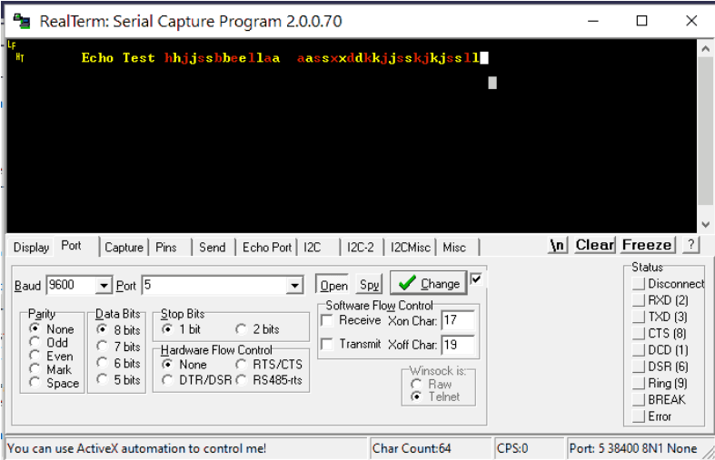

Conclusion

By Performing this Experiment I came to know about the UART Communication Protocol of ATMega32.

**Experiment-8 Post Lab Exercise**

Student Name: Aryan Langhanoja

Enrollment No: 92200133030

**Answer the following questions:**

1. What is the function of RXEN and TXEN register UCSRB?

* The RXEN (Receiver Enable) and TXEN (Transmitter Enable) registers in the UCSRB (USART Control and Status Register B) of AVR ATmega32 are used to enable the receiver and transmitter, respectively, of the USART (Universal Synchronous/Asynchronous Receiver/Transmitter) module. When these bits are set, the USART can receive or transmit data.

1. To which register/registers RXC and UDRE belongs to?

* The RXC (Receive Complete) and UDRE (USART Data Register Empty) flags belong to the UCSRA (USART Control and Status Register A) register of AVR ATmega32. RXC is set when unread data is available in the receive buffer, indicating that a receive operation has been completed. UDRE is set when the transmit buffer is empty and ready to receive new data to be transmitted.

1. Write the pin names of USB to TTL.

* The USB to TTL (Universal Serial Bus to Transistor-Transistor Logic) interface typically consists of the following pins:
* VCC: Power supply (usually 5V)
* GND: Ground
* TXD: Transmit Data
* RXD: Receive Data

1. What is baud rate and explain in your own words the importance of baud rate?

* Baud rate refers to the number of signal or symbol changes that occur per second in a data transmission. It determines the rate at which data is transmitted over a communication channel. In simpler terms, baud rate signifies how quickly data is sent over a communication link. The importance of baud rate lies in its role in ensuring reliable communication between devices. Matching the baud rate settings between the transmitter and receiver is crucial for proper data transfer. If the baud rates do not match, data may be received incorrectly, leading to transmission errors or data corruption.

1. Suppose Fosc=12 MHz and required baud rate= 9600 bps, what is the UBRR value?

* To calculate the UBRR (USART Baud Rate Register) value for a given baud rate and system clock frequency, you can use the following formula:

UBRR = (Fosc / (16 * baud rate)) - 1

Given: Fosc = 12 MHz Baud rate = 9600 bps

Plugging in the values:

UBRR = (12,000,000 / (16 * 9600)) - 1 = (12,000,000 / 153600) - 1 ≈ 77.08

Since UBRR must be an integer value, rounding it up to the nearest integer:

UBRR ≈ 78

So, the UBRR value for Fosc = 12 MHz and a required baud rate of 9600 bps is 78.